COSEE Hands-On Activities
USA Science & Engineering Festival
Grouping: Tools

Lesson/Activity: Building a Hydrometer
http://www.ecawa.asn.au/home/jfuller/liquids/hydrometers.htm

A hydrometer is a device used to compare the densities of liquids. You can easily make your own hydrometer using anything that can be made to float with part of itself projecting above the surface of the liquid. The instructions below outline how to make your own very inexpensive hydrometer using readily available parts.

Materials
- Ruler
- Permanent marker
- Drinking straw
- Small nails
- Plasticine or modeling clay
- Glass containers
- Water
- Salt

Instructions

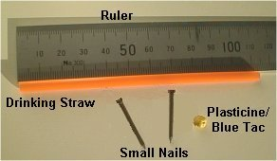  Parts needed to make your Hydrometer | 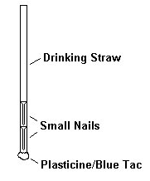

You will find it easiest if you mark a scale on your Hydrometer so that you can accurately judge how low it floats in different liquids.

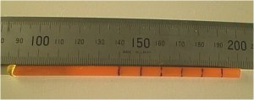 | Mark a Scale on your Hydrometer to make it easier to see how far it sinks in the liquid.

In the photographs below the Hydrometer is placed in Fresh and Salt water. The depth at which it floats indicates the relative densities of the two liquids.

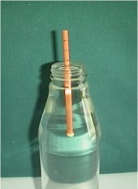  The Hydrometer in Fresh Water | 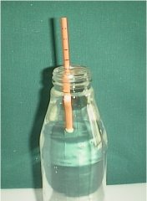  The Hydrometer in Salt Water

When measuring the depth to which the Hydrometer sinks you need to be aware of the Meniscus formed between the straw and the water surface. The accepted practice is to measure from the bottom of the meniscus in line with the liquid surface.

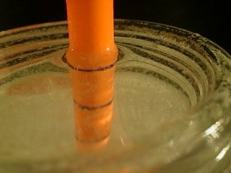  A close-up view of the straw in water showing the curved "meniscus" due to attraction between water molecules and the straw. | 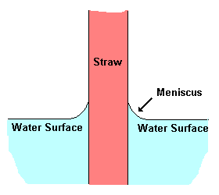  When measuring the depth of the straw in the liquid measure from the bottom of the meniscus in line with the water surface.

